WORD-COUNT
Develop a MapReduce program to calculate the frequency of a given word in a given file.
Input.txt
hadoop python bigdata hadoop python hadoop data

wordcount.py
# MapReduce Word Frequency in Python
word_to_find = "hadoop"
# Open file
with open("Big Data Analytics\WordCount\input.txt", "r") as file:
data = file.read().lower()
# Split into words
words = data.split()
# Count frequency
count = words.count(word_to_find)
# Output
print("Word :", word_to_find)
print("Frequency :", count)

“This program reads a text file, splits the words, counts how many times the given word appears, and prints its frequency.”

1. What is MapReduce?
Answer:
MapReduce is a programming model used to process large amounts of data in distributed systems like Apache Hadoop.

2. Why do we use MapReduce?
Answer:
To process huge datasets quickly by dividing work among multiple machines.

3. What is the aim of this practical?
Answer:
To count how many times a specific word appears in a text file.

4. Which file did you use as input?
Answer:
I used input.txt, which contains sample words.

Code-Based Questions
5. What does open("input.txt","r") do?
Answer:
It opens the input file in read mode.

6. Why did you use lower()?
Answer:
To convert all words to lowercase so Hadoop and hadoop are treated the same.

7. Why did you use split()?
Answer:
To separate the text into individual words.
Example:
"hadoop python data"
becomes:
['hadoop','python','data']

8. What does count() do?
Answer:
It counts how many times the given word appears in the list.

9. What word did you search?
Answer:
I searched for the word:
hadoop

MapReduce Concept Questions
10. What is Mapper?
Answer:
Mapper reads input data and converts it into key-value pairs.
Example:
(hadoop,1)
(python,1)
(hadoop,1)

11. What is Reducer?
Answer:
Reducer combines same keys and calculates final count.
Example:
hadoop = 3

12. What is key-value pair?
Answer:
A pair where key is the word and value is its count.
Example:
(hadoop,1)

13. What happens between Mapper and Reducer?
Answer:
Shuffle and sort happen, where same keys are grouped together.

Hadoop Questions
14. What is Apache Hadoop?
Answer:
Hadoop is an open-source framework for storing and processing big data.

15. What is HDFS?
Answer:
HDFS stands for Hadoop Distributed File System. It stores data across multiple machines.

16. What is NameNode?
Answer:
NameNode manages metadata and file information in HDFS.

17. What is DataNode?
Answer:
DataNode stores actual data blocks.
18. Why did you use Python instead of Java?
Answer:
Python is simpler, shorter, and easier to understand for implementing the same logic.

19. What is the time complexity?
Answer:
Approximately O(n) because each word is checked once.

20. If the file is very large, will this work?
Answer:
Yes. MapReduce is designed to process very large datasets efficiently.

21. Can this count all words instead of one word?
Answer:
Yes, by using a dictionary or hash map.

22. What if the word is not present?
Answer:
Frequency will be zero.

This program reads a text file, converts text to lowercase, splits it into words, counts the frequency of a given word, and displays the result. It follows the MapReduce concept where mapping creates key-value pairs and reducing sums the counts.”

STUDENT-GRADE
Develop a MapReduce program to find the grades of students.
Create:
students.txt
Put this data:
Lily 85
Sara 72
John 60
Maya 45
Tulip 90
Studentgrade.py
# MapReduce program to find grades of students
with open("students.txt", "r") as file:
lines = file.readlines()
print("Student Grades:")
print("----------------")
for line in lines:
name, marks = line.split()
marks = int(marks)

# Grade logic
if marks >= 80:
grade = "A"
elif marks >= 70:
grade = "B"
elif marks >= 60:
grade = "C"
elif marks >= 50:
grade = "D"
else:
grade = "F"

print(name, ":", grade)
“This program reads student names and marks from a file, processes each student record, applies grading conditions, and displays the final grades.”

MapReduce Explanation
Map Phase
Reads records:
(Ali,85)
(Sara,72)
(John,60)

Reduce Phase
Assigns grades:
Ali → A
Sara → B
John → C

External Viva Questions

1. What is the aim of this practical?
Answer:
To assign grades to students based on their marks using the MapReduce concept.

2. What input did you use?
Answer:
A text file containing student names and marks.
Example:
Ali 85
Sara 72

3. Why did you use split()?
Answer:
To separate student name and marks.

4. Why did you convert marks into integer?
Answer:
To perform comparison operations.

5. What grading criteria did you use?
Answer:
80+ → A
70+ → B
60+ → C
50+ → D
Below 50 → F

6. What is Mapper?
Answer:
Mapper reads input data and creates key-value pairs.
Example:
(Ali,85)

7. What is Reducer?
Answer:
Reducer processes marks and assigns grades.

8. What is key-value pair?
Answer:
Key is student name and value is marks.
Example:
(Ali,85)

9. Why use MapReduce here?
Answer:
To process student records efficiently, especially for large datasets.

10. What happens if marks are 95?
Answer:
Grade A will be assigned.

11. What happens if marks are 40?
Answer:
Grade F will be assigned.

12. Can this work for 10,000 students?
Answer:
Yes, MapReduce is designed for large datasets.

13. Why use Python?
Answer:
Python is simple, readable, and requires fewer lines of code.

14. What file mode did you use?
Answer:
r
Read mode.

“This program reads student data from a file, separates names and marks, checks grading conditions, assigns grades, and displays the final result using the MapReduce concept.”

TITANIC
Develop a MapReduce program to analyze Titanic ship data and to find the average age of the people (only male) who died in the tragedy. How many persons are dead in each class (only female).

Titanic.csv
Name,Sex,Age,Class,Survived
John,male,35,1,0
David,male,28,2,0
Mike,male,40,3,1
Sara,female,22,1,0
Anna,female,30,2,0
Maya,female,18,3,0
Rose,female,25,1,1
Tom,male,45,1,0

titanic_analysis.py
import csv

male_age_sum = 0
male_count = 0

female_dead = {"1": 0, "2": 0, "3": 0}

with open("Big Data Analytics\\Titanic\\titanic.csv", "r") as file:

data = csv.DictReader(file)

for row in data:

if row["Sex"] == "male" and row["Survived"] == "0":
male_age_sum += int(row["Age"])
male_count += 1

if row["Sex"] == "female" and row["Survived"] == "0":
female_dead[row["Class"]] += 1

print("Average age of dead males:",
male_age_sum / male_count)

print("\nFemale deaths by class:")

for cls, count in female_dead.items():
print("Class", cls, ":", count)

“This program reads Titanic passenger data from a CSV file, filters male passengers who died, calculates their average age, then filters female passengers who died and counts them class-wise.”

MapReduce Explanation
Map Phase
Reads records:
(male,35,dead)
(female,class1,dead)

Reduce Phase
Calculates:
Average age = total age / count
Class-wise female deaths

External Viva Questions

1. What is the aim of this practical?
Answer:
To analyze Titanic data using MapReduce.

2. What conditions did you apply?
Answer:
- Male + Dead → average age
- Female + Dead → class-wise count

3. What file format did you use?
Answer:
CSV
Comma-separated values.

4. Why use csv.DictReader?
Answer:
To read CSV data column-wise using column names.

5. What does Survived = 0 mean?
Answer:
Passenger died.

6. What does Survived = 1 mean?
Answer:
Passenger survived.

7. Why only male passengers?
Answer:
Because the problem statement asks for average age of dead males only.

8. Why use dictionary?
Answer:
To store female death count class-wise.

9. What classes are there?
Answer:
1st class
2nd class
3rd class

10. How is average age calculated?
Answer:
Average = Total Age ÷ Number of males

11. What is Mapper?
Answer:
Mapper reads passenger records and filters required data.

12. What is Reducer?
Answer:
Reducer performs aggregation like average and counting.

13. What if no male died?
Answer:
Average cannot be calculated; division by zero should be handled.

14. Why use Python?
Answer:
Python is simple, readable, and easy for data analysis.
“This program reads Titanic CSV data, selects male passengers who died and calculates their average age. Then it selects female passengers who died and counts them according to passenger class.”

MONGODB CRUD OPERATIONS

Mongo DB: Installation and Creation of database and Collection CRUD Document: Insert, Query, Update and Delete Document.
[first mongodb server installed karana hai https://fastdl.mongodb.org/windows/mongodb-windows-x86_64-8.3.1-signed.msi yaha se then mongodb shell https://downloads.mongodb.com/compass/mongosh-2.8.3-win32-x64.zip yaha se...]
Open CMD and check version:
mongosh --version

Start Mongo Shell
Open CMD:
mongosh
You’ll see:
test>
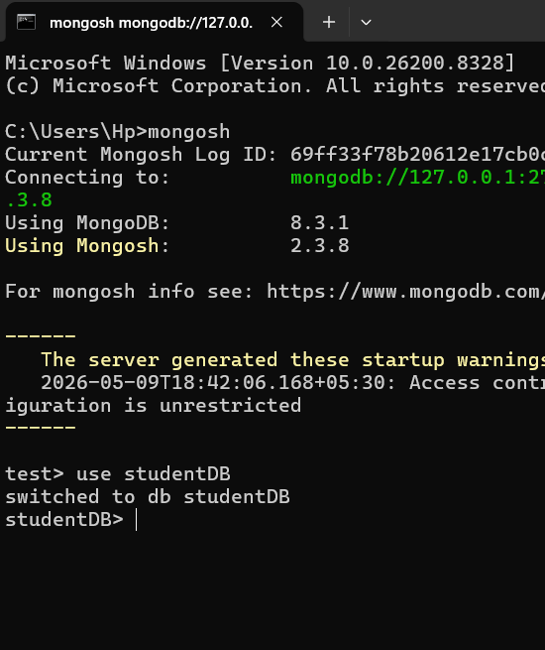
Create Database
Command:
use studentDB
Output:
switched to db studentDB

Create Collection
Command:
db.createCollection("students")
Output:
{ ok: 1 }

INSERT Document
Command:
db.students.insertMany([
{name:"Sara", age:22, city:"Mumbai"},
{name:"Rahul", age:20, city:"Delhi"}
])

Output:
acknowledged: true

QUERY Document
Show all data:
db.students.find()
Output:
Ali
Sara
Rahul

UPDATE Document
Command:
db.students.updateOne(
{name:"Ali"},
{$set:{age:25}}
)
Output:
matchedCount:1
modifiedCount:1

DELETE Document
Command:
db.students.deleteOne({name:"Rahul"})
Output:
deletedCount:1

In this practical, I installed MongoDB, created a database and collection, then performed CRUD operations—Create, Read, Update, and Delete—on student documents.

External Viva Questions

1. What is MongoDB?
Answer:
MongoDB is a NoSQL database that stores data in document format.

2. What does NoSQL mean?
Answer:
Not Only SQL. It stores unstructured or semi-structured data.

3. What is a document?
Answer:
A document is a record stored in JSON-like format.
Example:
{
"name":"Ali",
"age":21
}

4. What is a collection?
Answer:
A collection is a group of documents.

5. What is a database?
Answer:
A database contains collections.

6. What is CRUD?
Answer:
C → Create
R → Read
U → Update
D → Delete

7. Which command creates a database?
Answer:
use studentDB

8. Which command creates a collection?
Answer:
db.createCollection("students")

9. Which command inserts data?
Answer:
insertOne()
or
insertMany()

10. Which command displays data?
Answer:
find()

11. Which command updates data?
Answer:
updateOne()

12. Which command deletes data?
Answer:
deleteOne()

13. Difference between SQL and MongoDB?
Answer:
SQL → tables and rows
MongoDB → collections and documents

14. What format does MongoDB use?
Answer:
BSON (Binary JSON)
“In this practical, I installed MongoDB, created a database named studentDB, created a students collection, inserted documents, retrieved data, updated records, and deleted documents using CRUD operations.”

